Dear Reader,
What if I told you the absolute biggest stock breakthroughs every single year happen within a seven-day period…
And that there’s a way to predict, with absolute certainty, the exact day… the exact hour… and the exact minute these breakthroughs will explode?
And these eruptions… they’re not just predictable – they’re also massive…
A mind-blowing 733% BIGGER than any “normal” move a stock might make.
I’m here today to show you how you could use this anomaly to make profits as high as 103% ON AVERAGE… 52 AMAZING TIMES A YEAR…
Returning annualized gains of over one million percent.
It might sound crazy at first. I wouldn’t blame you for being skeptical.
But the fact is, it gets even crazier…
Because you can position yourself – a full two days ahead of time – to profit from these price eruptions.
In fact, I’m going to show you how you could use this two-day advantage to turn these eruptions into gains that go way beyond “average”…
Gains of 150%, 231%, 439%, even 954% in seven trading days or less, over and over again.
I’ll even show you how you could start collecting mega-gains like these right now.
And just to prove it to you, you’re about to see all the details on how to play Delta Air Lines two days ahead of time for a gain I’m estimating to be 112%...
A gain you can cash in on in seven days or less.
My name is Chris Johnson. I’ve spent over two decades studying these price eruptions and predicting them two days ahead of time. And, frankly, making a ton of money.
Imagine what you could be doing right now, given the chance to double your money in seven trading days – over and over again. You might be on your fishing boat in the Caribbean… ready to pull into your own private, million-dollar dock.
That’s why it’s important to listen up. For the first time ever, you’re about to see, step by step, exactly how you can identify these price eruptions two days ahead of time… and turn them into cold, hard cash.
You may have heard me predicting these price eruptions on the news…
Like CNBC, Fox Business News, Bloomberg News, and others.
You may have read about my research in The Wall Street Journal, Barron’s, USA Today, or The New York Times.
You may have even profited from one of my recommendations over the years…
The same ones that have placed me in the top 2% of more than 10,000 independently ranked investing experts.
But while I’ve spoken publicly for years about how predictable these price eruptions are, I’ve never revealed the proprietary system I use to identify them two days ahead of time.
That’s because up till now, only private clients who paid high commissions to a boutique investment firm have had access to my recommendations.
But now, for the first time, I’m sharing the power of my system with Money Morning readers.
My system shows how you can turn these big moves into gains of 103% on average in only seven days.
Not only that, but you can do it over and over again. Week in and week out. 52 times a year. With above average gains running as high as 954% – over 10 times your money.
This system is so consistently reliable, I’m putting my personal guarantee behind it – it’ll produce a winner 8 out of every 10 times we go to bat together.
That’s right. You get my personal GUARANTEE on that, as you’ll see in a moment.
That’s how powerful this system is.
But most importantly…
Pulling in 231%, 439%, and 954% Profits Has Never Been Easier or More Reliable Than It Is Right Now…
That’s because these HUGE, predictable profits are easy to see, using my stock market seismograph…
My system tracks price eruptions the way a sophisticated seismograph can track the slightest tremor 500 miles away.
But in my case, it tells me exactly when the big quake is coming two full days ahead of time.
And these price eruptions…
They’re easy to see today…
They’ll be easy to see tomorrow…
And they’ve been easy to see for the past three years…
In fact, going back to January 1, 2014 – and right up to this very day…
I applied my stock market seismograph to every one of the 6,000 price eruptions that occurred on the biggest… the most liquid… and the “safest” stocks on the S&P 500.
And what I found was that my seismograph correlated to 8.3 out of every 10 huge moves – two days ahead of time.
Again, that’s from January 1, 2014… right up to the present day, to eliminate any lag, and eliminate any doubt.
Now, using examples from my extensive historical testing…
Let me show you the kind of money you could be looking at.
Here’s a stock market seismograph of Akamai Technologies. You may have heard of it. It’s a cloud service provider.
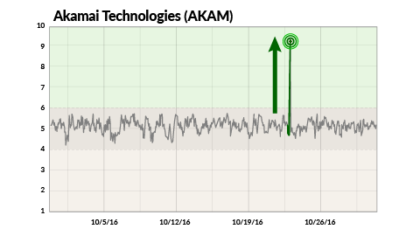
See that big spike in the chart?
Looking at all the past data, my seismograph detected a new triple-digit profit opportunity on October 21, 2016. That was two days before the price eruption…
Once again leaving plenty of time to get in before the big move played out. Which is exactly what happened.
Within a seven-day period, starting on October 25, Akamai shares shot up a hot 16% – and fast!
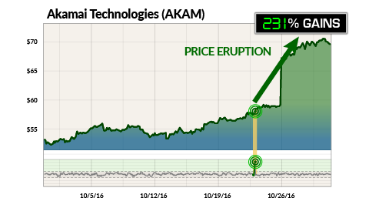
But here’s the thing… using my system, you could have turned that fast spike into 231% gains in just seven trading days.
Let me give you another recent example…
This is a stock market seismograph of a company called People’s United Financial, a savings and loan holding company. The stock ticker is PBCT. Most people have never heard of this company.
On October 18, 2016, my seismograph spotted an opportunity for triple-digit profits.
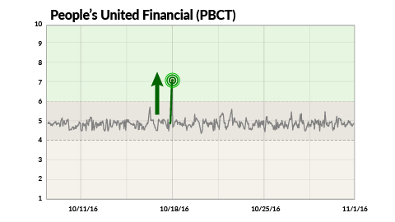
See that big spike on October 20? That shows People’s latest big price eruption.
This would have given you plenty of time to get in – and position yourself for big gains – before the stock shot up. In fact…
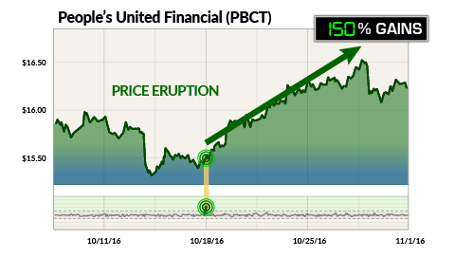
Using my system, you could have turned that jump into 150% gains by October 27. Just seven days later.
And People’s is just one of hundreds of stocks that experience huge, seven-day price eruptions.
Take a look at my seismograph of NVIDIA, the semiconductor company.
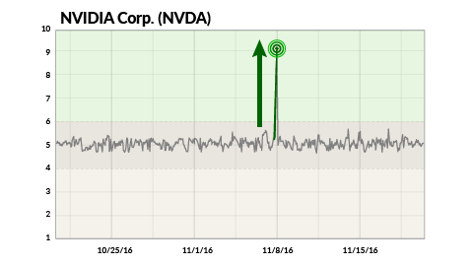
See that big spike?
That’s the most recent price eruption on NVIDIA.
Two days before the eruption, on November 8, the seismograph extracted this triple-digit opportunity from a mass of data – giving you plenty of time to get in before the eruption.
Sure enough, NVIDIA experienced a massive price eruption on November 10, jumping 33%.
And by following my seismic profit system, you could have turned that eruption into 954% gains in only seven trading days.
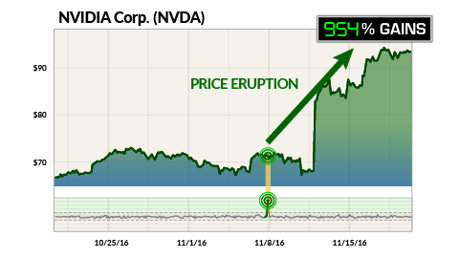
That’s more than TEN TIMES your money in seven days!
Imagine starting out with $1,000 on Monday and heading to the bank with more than 10 grand seven days later.
Exceptional? Of course. Heck, even a fraction of this would impact your bottom line.
Just consider that in the last three years, NVIDIA has typically moved an average of 2% during any given seven-day period in the market.
But during this seven-day price eruption, NVIDIA moved an amazing 33%.
That’s a 17 TIMES BIGGER MOVE over those seven days than at any other time of the year!
My stock market seismograph is designed to predict these price eruptions with pinpoint accuracy two full days before they occur.
It proves that stocks I’m able to select make the biggest price moves within a very specific seven-day period, over and over again...
And that my method gives me the inside track on when these moves will take place, right down to the day… the hour… and even the minute.
In fact, my three-year analysis of the S&P 500 shows that stocks make 733% BIGGER moves on average during these precise seven-day periods.
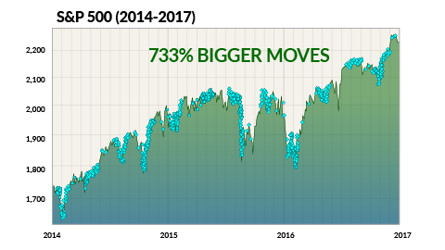
And of course, the bigger the move, the bigger the potential profits…
Best yet, because we know exactly when these price eruptions will occur, you can position yourself to profit two full days before the eruption occurs. And you can pocket any gains within just seven trading days.
So here’s my question: If you knew that a stock made 17 times bigger moves during these seven days…
And you knew EXACTLY when this price eruption was likely to happen, right down to the minute in many cases…
And you had access to a trading system with my personal GUARANTEE to hit big on 8 out of every 10 price eruptions it uncovers…
Why would you be risking your money any other way?
To explain how it works, let’s go back to the earthquake concept for a moment.
The stock market seismograph shows you the wave pattern that creates these massive price eruptions, just as a true seismograph shows you the seismic waves that move through the earth’s crust during an earthquake.
But the magnitude of those seismic waves is actually measured by the Richter Scale. It’s a mathematical tool that tells you how big the wave actually is.
And that’s exactly what my proprietary tool does. Only instead of measuring the size of earthquakes, it measures the potential size of the price eruption.
It’s my own Richter Scale for stock prices...
And every single day, my seismograph calculates the Richter Scale Score for every stock in the S&P 500.
The score itself is made up of 10 separate mathematical equations. These are based on key factors that are scientifically proven to trigger price eruptions.
I’ll take you through the calculations in a moment.
But for now, let’s just say that each one of those equations boils down to a simple “yes” or “no” decision that’s represented by a “0” or “1” – just like computer binary code.
A score of 7 or above means that the stock is poised to experience a massive price eruption to the upside 8 out of 10 times.
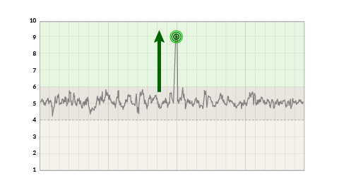
A score of 3 or below means that the stock is set to experience a major price break to the downside 8 out of 10 times.
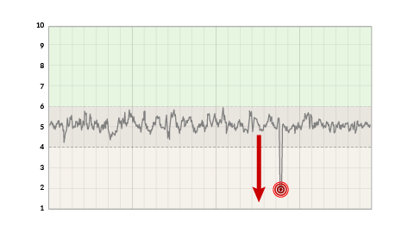
And a score between 4 and 6 means the stock may experience some minor tremors in the market, but nothing big enough to trigger massive gains. So my system discards those stocks automatically.
Every day, my seismic profit system collects over 750,000 data points on individual stocks. It searches for all potential price eruptions with a Richter Scale Score of 7 or above.
And the Richter scale score is incredibly accurate.
In fact, going back and applying my Richter Score to over 6,000 price eruptions… it racked up an incredible 83% win rate.
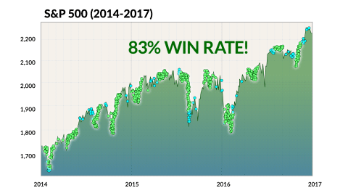
Of course, as everyone knows, hindsight is 20/20. I can’t guarantee what will happen in the future. Nobody can do that.
But the research here is undeniable.
It shows you could have collected, on average, 103% gains on each of these price eruptions using my strategy.
And please note: The 103% AVERAGE includes every single trade, both winners and losers…
And of course, that’s just the average. You’ll have the very real opportunity to post exceptional gains of 231%... of 439%... and gains running as high as 954%.
And the really amazing fact: You could have collected each win in seven trading days or less!
Let me show you how this works with another concrete example – a price eruption on Garmin from July 27, 2016.
Now, two days before the price eruption, Garmin’s Richter Score hit an 8.
That meant there was a huge probability that the stock was about to make a massive move to the upside.
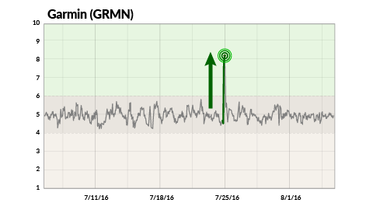
Most traders had no idea this move was coming.
Wall Street was shorting the stock left and right. Even option buyers were betting against the stock.
But if you were paying attention to the Richter Score, you would have known that this was one stock you did NOT want to short.
Instead you could have gotten in two days ahead of time.
And when the stock surged more than 23%...
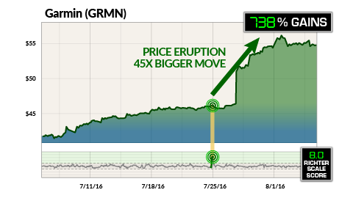
You could have turned that big jump into 738% gains by August 3!
Look, on any given seven-day period, Garmin moves less than 1%… 0.52%, to be exact. It’s minuscule.
And this is the way most big stocks move… like slugs.
Without these big price eruptions, it would take Garmin shares over a year to move 23%.
But last July, it jumped 23% in just seven days.
That’s a 45 times bigger move in seven trading days than at any other time in the market!
Now, 23% is a fast move. You rarely see stocks spike that way…
But using my system, you can take these fast moves and slingshot them into astronomical profits.
In fact, using my trading method, you could have turned that 23% move into a massive 738% gain within those seven days.
And it’s so consistently reliable that you know right down to the day, hour, and minute when these eruptions will likely occur.
So again, I just have to ask: Why wouldn’t you use price anomalies like this and make a fortune for yourself?
Especially when you could do it over and over again.
On every stock in the S&P 500.
Take a look at this price eruption on Microchip Technology…
Ahead of the eruption, the Richter Score on Microchip was an 8, signaling the potential for a solid price jump.
Sure enough, the stock surged 8% in a week, which is impressive considering how fast it moved.
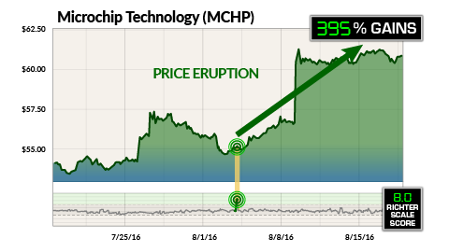
But you could have used my seismic profit system to turn that price eruption into a 395% win in just seven days!
Or consider Paychex.
The stock market seismograph pinpointed a price eruption on June 30, 2016.
Ahead of the eruption, the Richter Score on the stock was a 9. That signaled that Paychex was likely to make a major move to the upside.
Sure enough, the stock rocketed more than 10% in five days. Now, that’s a pretty big jump…
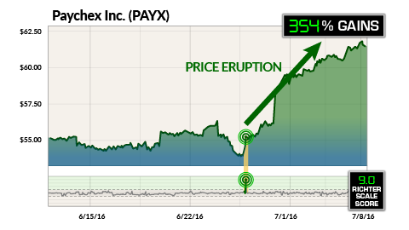
But your potential profit trading this event the way I trade? That’s a whopping 354%.
Nothing else on earth can pinpoint these fast moves and turn them into these huge potential gains the way that the stock market seismograph can.
You’re going to see exactly how in a minute…
In fact, the stock market seismograph pinpointed yet another price eruption on the chemical company Albemarle on May 10, 2016.
Two days ahead of the eruption, the Richter Scale Score was a 9. So there was a very high probability the stock would erupt to the upside…
And it did, moving more than 15% higher.
In fact, Albemarle jumped 31 times higher than normal during this seven-day price eruption. That’s how powerful these anomalies are.
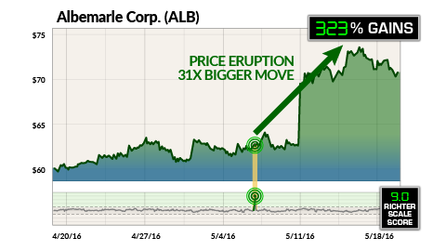
Best of all, with my seismic profit system, you could have turned that jump into a 323% gain in seven days…
If you knew what was coming.
Here’s another example...
Take a look at Cintas Corporation. It’s one of the biggest uniform suppliers in the country. Its price eruption on July 19, 2016, shocked everybody.
Most traders were clueless this jump was coming. In fact, short interest on Cintas rocketed higher ahead of the price eruption – to its highest levels in a year. So Wall Street actually expected a plunge in the stock!
But if you’d seen the Richter Scale Score of 7, you would have known better. Sure enough, the stock spiked nearly 10% in just one day. And another 11% over the next seven days.
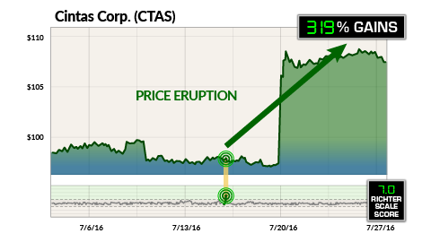
You could have used my seismic profit system to turn that price eruption into 319% profits in only seven days, as you’re about to see.
You can also profit when the stock breaks to the downside.
Now, if the Richter Score is 7 or above, I know there’s a high probability that the stock will erupt to the upside.
Using my system, you can turn those price eruptions into 150% gains, 319% gains, or even 954% gains.
But that’s not all…
My system predicts moves in the opposite direction as well.
If the Richter Scale Score is 3 or below, it means that there is a high probability that the price will break to the downside.
And because you know the exact day and time the break will occur, you can turn that “bad news” plunge into 115% gains, 253% gains, and even 506% gains in seven days or less.
Look at MetLife, for example.
On February 1, 2016, the Richter Score hit a low of 1. Meaning there was a high probability that the stock was about to break to the downside.
Sure enough, MetLife shares plunged more than 16% starting on February 3. If you were a shareholder, you would have been reaching for the Maalox as you watched your investment crumble.
But if you knew the Richter Score, you would have known two days ahead of time that the plunge was coming.
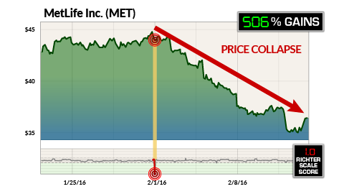
And you could have used my seismic profit system to turn that stomach-churning dive into a 506% gain in seven trading days.
How can I predict when a stock price is about to erupt?
What makes the Richter Scale such a powerful predictor of big price moves?
Simply put: Its incredible accuracy.
The score is based on 10 key factors that every big stock eruption displays. And my system pinpoints these factors two full days ahead of time.
It assigns one point to each critical piece of the pattern…
- Is the stock’s 50-day moving average trending higher or lower?
- Is the current stock price above or below that 50-day moving average?
- Is the stock’s 200-day moving average trending higher or lower?
- Is the stock price above or below that 200-day moving average?
- Where is the stock’s 50-day moving average relative to its 200-day?
- Has there been any significant change in the stock’s price pattern ahead of the eruption?
- What is the distribution of the stock’s price, its volatility, over the previous month leading up to the eruption?
- What is the option activity ahead of an eruption? Are traders loading up on calls or loading up on puts?
- How many shares of the stock are sold short ahead of an eruption?
- What are the analyst ratings ahead of an eruption?
These are the 10 critical indicators that tell you if a stock is about to experience a major price eruption.
If the score is 7 or above, the stock is likely to erupt to the upside. And if the score is 3 or below, the stock is likely to take a plunge.
All of my research, on over 750 million historical stock price and data points, for the past three years, shows that the Richter Score can pinpoint which stocks are about to experience a massive price eruption with 83% accuracy.
Best of all, with the Richter Score you’ll have the opportunity to turn those big moves into gains of 103% ON AVERAGE in only seven days.
And of course, that’s just the average. You’ll have the opportunity to pocket as much as nine times that amount.
So What Is It That Triggers a Massive Stock Price Eruption?
The phenomenon behind these anomalies – these specific and unique price eruptions – was first documented in 1968 by two men named Raymond Ball and Philip Brown.
Oddly enough, they were both from Australia. Two young men, passionate about numbers and working on their PhDs at the University of Chicago, the hub of financial research.
And what they proved turned the financial world on its ear. In fact, today their discovery is cited as the most “influential research in accounting during the last century.”
Yet I’d venture to say fewer than 1 in 1,000 investors has ever read their paper.

And what they proved is so simple, so direct, and so miraculous that it’s astounding.
Namely, that a company’s earnings can directly predict the direction of its stock price, up or down.
It’s a finding that blew away over 100 years of “efficient market theory”… and identified stock anomalies that could make people extremely rich.
Now usually, the earnings a company makes are kept secret. Yet because of a 1934 SEC regulation, companies are forced to make certain accounting information public…
And when that happens, my seismic profit system swoops in and turns those anomalies into massive profit opportunities.
And because you know the exact date and time of the event, you can legally position yourself two days ahead of it – and play it for a shot at triple-digit gains.
In fact, multiple studies show it’s the only consistent price anomaly that has not been arbitraged away by sophisticated Wall Street trading systems.
That’s why I play earnings – because they are scientifically proven to deliver “abnormal returns.” That is, returns that are much bigger than typically expected.
And using my seismic profit system, I can leverage those “abnormal returns” into triple-digit gains over and over again.
Why I Don’t Give a Darn What Wall Street Says – and Why You Shouldn’t Either…
Now, I’ve known a lot of people who’ve tried to trade on earnings, and most of them fail miserably. I know because I’ve spent the last 20 years studying every mistake they make.
Their biggest problem is noise. That’s why my seismic profit system filters over 750,000 data points on hundreds of stocks every single day.
That’s why I deal in hard data. I’m not dealing in opinions, talking heads, spin, emotions, or any other BS.
Data is fact.
And that’s what enables me to pinpoint the biggest price eruptions that come from a company’s earnings.
Because when you can know two days ahead of time, with up to 83% accuracy, which way the earnings are going to go… you can make a bundle.
Gains like this...
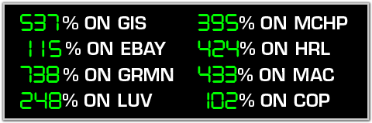
I could go on and on, but you get the point.
These eruptions are the single biggest source of abnormal returns in the market – bar none…
And they happen over and over again…
Let me show you what I mean, and how you could have grabbed…
447% Profits on a Huge, Predictable Price Eruption.
Just take a look at the stock seismograph for health care company Varian Medical.
Heading into the company’s July earnings, the Richter Score on Varian hit an 8. That meant the stock was ripe for a major pop.
At the time, Varian was the sixth most shorted stock in the entire S&P 500!
Not only that, but traders were loading up with puts – a sure sign they were banking on the stock to fall.
This is exactly the type of profit anomaly my seismograph targets.
Because if Varian Medical delivered, as my Richter Score indicated, the price would erupt.
All those short sellers would have to throw in the towel and buy back the stock. And option traders would have to unwind their positions.
And that would trigger a massive rally. Which lets me put their money in my pocket.
And that’s exactly what happened...
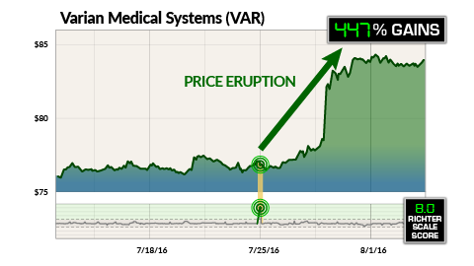
Using my system, you could’ve turned that massive rally into 447% gains… in only seven trading days.
Now, these profit anomalies occur on the opposite side as well…
Just look at Fox Entertainment.
Two days before its August 5, 2015 earnings report, the company’s Richter Score was a 2.
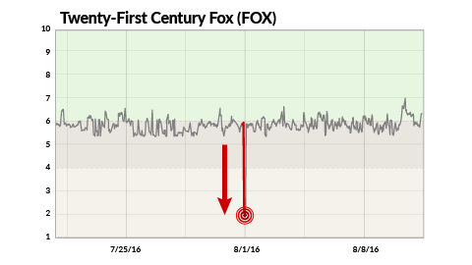
This showed the stock was about to break to the downside. But the Street was still betting on a turnaround.
The analysts loved the stock, with 9 out of 10 rating it a buy or a strong buy.
But if you knew my Richter Score, you would have known they were dead wrong.
In fact, major media stocks lost a total $37 billion in market value that week.
Based on my Richter Score, Fox Entertainment would likely suffer the same fate.
And just like the score predicted, Fox dropped nearly 12% when the earnings went public.
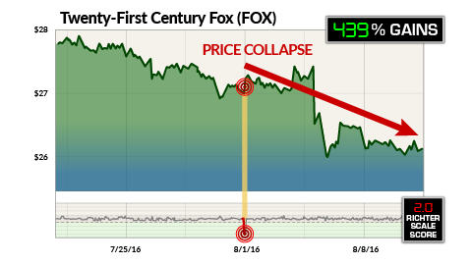
You could have played that price plunge for 439% gains in only seven trading days.
When you can capture cash like this over and over again all year long, week after week… you can stockpile a lot of cash very quickly.
And it makes sense, really.
That’s because my system scores every stock in the S&P 500 before its earnings hit the news. And it pinpoints any stock with a Richter Score of 7 or above or 3 or below.
And when I’m running things in real time, I won’t just stop there…
Using the data generated by my system, every stock you see will be put through a rigorous “confirmation screening” before I recommend it.
You see, my goal is to absolutely eliminate any opportunity that does not have the potential for a triple-digit windfall… without taking on triple-digit risk. My confirmation screening looks for things like:
- Splits, mergers, acquisitions, or spin offs.
- Feeding frenzies ahead of earnings.
- Technically overbought or oversold situations.
- Buy-the-rumor or sell-the-rumor situations.
- Technical support or resistance.
And let me confess something right now… this extra confirmation check means that I simply will not recommend some profit opportunities that my Richter Score uncovers.
But honestly, I’m sure you’ll agree that it’s worth missing a few potential profit points to give you the best chance at…
- Banking average gains of 103%...
- Profits on 8 out of every 10 trades...
- Above-average shots at 954% or more.
This unique way of making money is extremely easy to use… simple… it’s backed by years of success… and it has the potential to put hundreds of thousands in your pocket, year after year.
Now a 103% average return per trade is amazing. But when you can do it in seven days, it’s almost obscene. And if you cashed in every seven days, the return would blow your mind.
Go ahead and calculate the annualized rate of return.
You know what you’ll get? 1,069,016%. That’s more than a one million percent annual rate of return.
Now do you see why I have dedicated my entire career to trading earnings? Because it’s the most lucrative game in the market.
Now, let’s be clear: I’m not promising you’ll see 103% every seven days.
It’s possible there are going to be plays that deliver less than that, as well as some rocket ships that deliver far more than that…
Like the 954% returns you could have banked on NVIDIA last November.
And please remember, all investing carries risk, no matter how much data you have on your side.
But with big moves like these and the potential for a remarkable 83% win rate...
With my 20-plus years of analyzing earnings in incredible detail…
And my confirmation screening that eliminates companies not likely to make a big move in the right direction…
You can see why I’m willing to guarantee that 8 out of 10 recommendations will be winners – each one with the potential to double your money in seven days.
My Choice: Predict Hurricanes… or Make Big Money on Stocks
Look, I'm a quant jock. I love math. I love systems and analyzing patterns. And, quite frankly, I’m really good at it.
When I discovered my skill in college, I was told I should either become a stock analyst… or a meteorologist...
Because both those jobs require taking massive amounts of constantly changing data and turning it into a predictive tool.
So I could use my passion to predict hurricane paths… or to predict big stock moves.
For me it was an easy choice.
I took a job at Prudential Securities in the summer. And I loved it so much, I became a licensed broker while still in college.
Back then, Wall Street was a lot less sophisticated. As long as you knew which guru to listen to on the Squawk Box, you could make money.
But suddenly, as investing gurus like Peter Lynch and Warren Buffett gained popularity…
Main Street investors started paying more attention to the market.
And as “regular” investors started getting more sophisticated, I noticed the market started to move in odd ways. I soon realized that if you could predict that behavior, you could make a killing.
Not surprisingly, a lot of this “odd” movement would come from earnings. In fact, it may well be the only source for finding huge price anomalies you can get rich on.
So I set out to determine why some earnings trigger massive price eruptions and others did not – and more importantly, to figure out if I could predict it.
I started charting stock movement. Believe it or not, at first using a pencil and graph paper.
As the years went by, my graph paper turned into an Excel spreadsheet. Then a massive database.
Then it morphed into a sophisticated algorithm. And that’s what I use today to calculate my Richter Score.
In fact, I collect more than 750,000 data points on the S&P 500 stocks every single day… then use this data to calculate my Richter Scores.
This rich source of data is part of the reason I’ve been so effective in helping my former private-money clients make huge profits.
In fact, my trading recommendations have been so successful that I’m ranked in the top 2% of investing experts in an independent listing of more than 10,000 financial analysts, hedge fund managers, and corporate insiders.
It’s also why I’m frequently asked to appear as a guest on national media outlets such as CNBC, Fox Business News, and Bloomberg News…
And why publications like The Wall Street Journal, The New York Times, and Barron’s call me to ask my opinion on market trends.
Why I Don’t Play Wall Street’s Game
The bottom line is this: If I can get a 100% gain in seven days or less, over and over again… I'm taking the cash.
And the best way to capture a ton of these triple-digit winners – in the shortest amount of time – is to trade earnings the way that I am showing you today…
In fact, it’s the only way that I know of that could have turned a 33% move into a 954% profit.
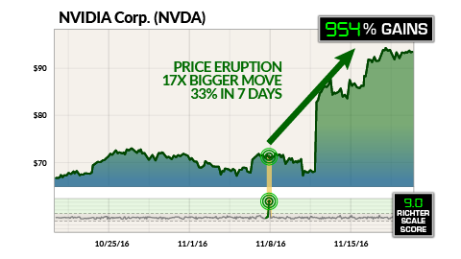
That’s why I recommend the simplest of all fast-money plays.
Simple options. Now, I’m not talking about those risky, complicated options you often hear about. I’ve got zero interest in high-risk lottery ticket stuff.
I’m talking about super-conservative, extremely simple moves you can make in about a minute, with the lowest risk possible…
And the LEAST amount of cash on the line, to boot. It only makes perfect sense when you want to generate a lot of cash fast and with little effort.
Let me show you what I mean, using my extensive historical testing.
Take a look at General Mills…
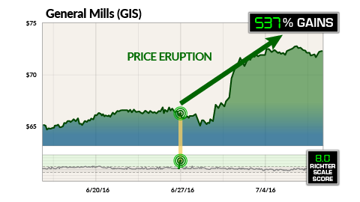
Two days ahead of its earnings, on June 27, General Mills had a Richter Score of 8. And the stock was trading at $66.19.
Now, you could have plunked down $66,190 to buy 1,000 shares of General Mills…
And you would have earned a pathetic 3% dividend in 12 months, which theoretically would have earned you a couple grand on your money...
Or you could have made a short-term earnings play my way for as little as $710!
And you would have banked 537% gains on the price eruption on June 29.
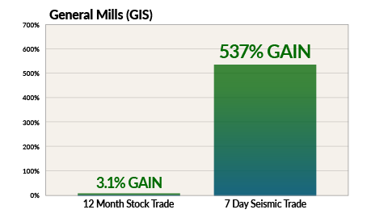
That’s $3,810 in profits in seven trading days. Cold, hard cash.
Not only that, but instead of forking over more than $66,000 in cash, you were in for less than a grand.
Now, I don’t know about you… but I would MUCH rather plunk down $710 for a chance to pocket a quick $3,810 in profits in one week…
Than tie up $66,190 for a year just to collect, at best, a tiny dividend!
Trading this way allows you to jump in and out of the market with a small investment – and the opportunity to make thousands of dollars in just seven days.
Look, you can get into most of these amazing plays for as little as $230! And then keep doubling your stake over and over again… in just seven days or less.
Here’s some great proof…
You could have bought 100 shares of NVIDIA back in January 2014 for $1,567. It’s been a high flyer for the past three years. And you could have made an impressive $9,107.
But Trading My Way Could Have Made You 36 Times More Money…
All starting with the same $1,567.
The first opportunity was on February 10, 2014, two days before NVIDIA reported earnings. My Richter Score hit 10, signaling a big move ahead.
Trading with the help of the Richer Score, you could have pocketed $7,902 in seven trading days.
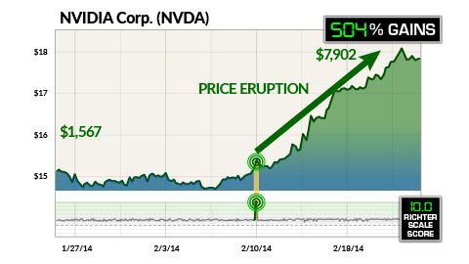
That’s a 504% return.
The second opportunity was on May 10, 2016, when the Richter Score hit a 9 – two days before NVIDIA was due to report.
If you’d reinvested the $7,902 in profits you collected on your first trade, you could have pocketed $34,713 just seven trading days later.
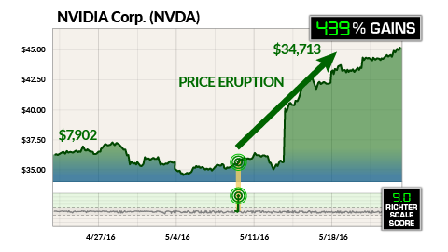
That’s a 439% return.
But you wouldn’t stop there. Because my Richter Score hit a 9 again on November 8, two days before NVIDIA’s earnings announcement.
If you’d reinvested the $34,713 you made on your second trade, you could have pocketed six-figure profits of $331,266 on NVIDIA trading the way I do.
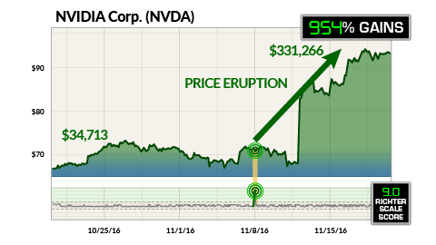
That’s a 954% return. In just seven trading days!
So to recap…
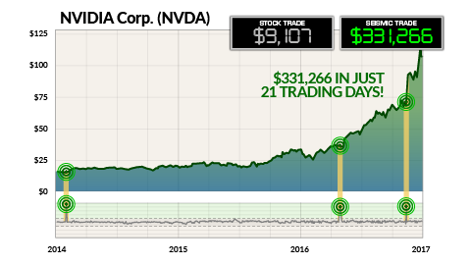
That’s a total of $331,266 in cash on just three trades. And you could have done it in only 21 total trading days.
So again, it just begs the question…
If you could bank $331,266 in cold, hard cash by trading for just 21 days total…
WHY would you wait three years to collect a measly $9,107…
When you could grab a mind-blowing 21,040% return just by rolling over your profits on three seismic events?
Granted, NVIDIA was an exceptional situation and playing it this way would have been no small feat. Explosive growth companies like this don’t come along every day, which is probably why so many traders missed out on this one!
Nonetheless, you can still position yourself for seismic profits by trading with my Richter Scale method.
That’s because you’re in and out in only seven market days. So you can redeploy your capital over and over again.
With the opportunity to transform a modest stake of $1,567 into $331,266.
Now, you may be wondering why somebody hasn’t figured out how to turn a company’s earnings into consistent profits this way before now.
Quite honestly, until just a few years ago, the system was too difficult to build. Because it takes an incredibly sophisticated model to accurately predict earnings moves.
Because of SEC regulations first instituted in 1934, every public company must reveal their insider information every quarter…
But they don’t all report on the same date. That means, in any given year, there’s roughly 23,000 earnings reported on hundreds of companies on all different dates…
And the profit opportunities are like little gems hidden inside a really big haystack.
It’s very difficult to accurately predict which events could trigger a price eruption … unless you sort through a ton of data for each stock.
It took me more than 20 years and over $50,000 of my own money to create a system sophisticated enough to potentially pinpoint winning trades with up to 83% accuracy.
And until now, I’ve only published a very few select investing articles based on my system. The rest of my research was reserved for my former private financial advisory clients only. And it’s allowed them to make some serious money...
So when Money Morning’s publisher, Mike Ward, called me to ask if there’s a way we can get this research to his readers… I was hesitant at first.
After all, I’m already very successful doing what I do on my own. And being ranked as high as I am, I get plenty of offers, all of which I’ve turned down.
But frankly, Mike is one persistent son of a gun. His mission is to show ordinary people how to thrive in the financial markets. This includes sharing strategies they can use to make extraordinary money – a mission I adhere to in my own life.
I knew he was serious when I saw the very generous offer he made to come on board with his publishing company. It was definitely “an offer I couldn’t refuse.”
So I left my private money line of work and agreed to share my system ONLY with Money Morning readers.
My only stipulation was that Mike had to limit the number of people I’d allow to get my research and recommendations.
You see, Money Morning has over 1.7 million daily readers.
My intent is to give a very high level of service. And I simply cannot accommodate that level of service with the thousands upon thousands of people Mike believes will want to get my Seismic Profits Alert as it goes “public” for the first time.
So we agreed to a strict limit of no more than 500 new people signing up at a time. Knowing that it would be a once-in-a-lifetime chance to see an influx of money most other people would never have a chance to see.
After all, I’m sure you agree not many people would turn down the opportunity to double their money every seven days on average.
Frankly, it’s crazy, right?
But when you accept my invitation to become a Charter subscriber to my Seismic Profits Alert today…
I promise to send you a MINIMUM of 52 trades a year, each targeting mouth-watering profits of at least 103%.
And if my historical testing is any guide, this is literally your best chance to double your money a minimum of 52 times in the next year.
Now, I'm not saying you’ll earn 100% every seven days. And no matter how big or small your successes are, I can’t possibly guarantee that every single trade will be a winner. Nobody can. That would be a fool’s claim.
But I believe in the power of my system. I’ve seen it in action. And when you see it for yourself, I know you’ll be thrilled with how quickly the profits add up.
It’s amazing how fast the money can pour in when you’re seeing opportunities to bank profits of 103% on average in under seven trading days… over and over again.
In fact, let me ask you: How would YOU like to pocket $27,897 in just two weeks?
Just consider last October…
When my Richter Score pinpointed eight plays the week of October 21… like an obscene pile of riches.
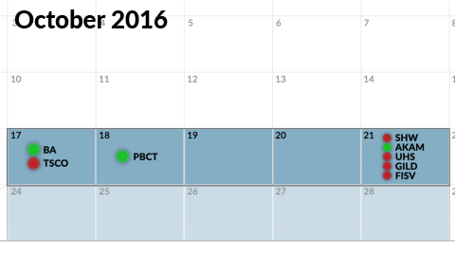
You could have played ALL EIGHT FOR AS LITTLE AS $2,927.
Now, this wasn’t some long-term stock play where your cash is locked up for months or years. All plays closed in seven trading days or less.
The average return on all eight plays was 152%. By the end of the first week, you could’ve pocketed $7,376.
Then how about banking $20,521 the following week?
Because the next week, you could’ve made a boatload of money again.
You could’ve made three different earnings plays starting on October 25 – and closed those plays for an average of 194% gains.
Invest $6,980, and you could’ve walked away with $20,521.
That’s a total of $27,897 for both weeks.
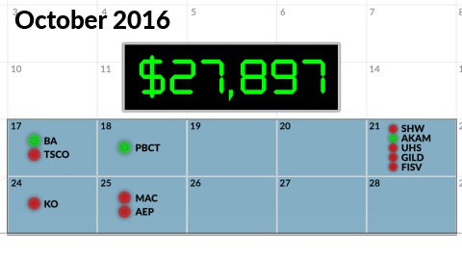
Now, of course not every price eruption is going to lead to gains. No investing strategy works 100% of the time…
But I’m telling you, trading this way is INCREDIBLY FUN.
It’s like getting a whole bunch of bonus checks all at once. And for you, there’s virtually NO WORK involved. Because I do all the heavy lifting.
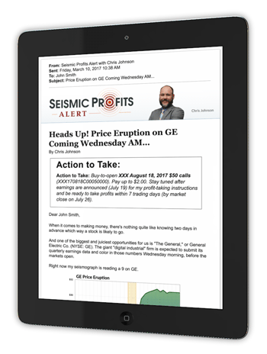
Let me be completely clear, I’m not giving you some piece of trading software you have to spend hours learning to use. You do NOT have to calculate the Richter Scale Score or get dirty with the data. I do ALL the work using my system.
What you’ll receive as a Seismic Profits Alert subscriber is so much more…
I tell you exactly why my proprietary system has flagged each trade. And I give you exact instructions on:
- What option to purchase…
- Exactly how to buy it and at what price…
- And, most importantly, how to get the biggest potential profits into your hands as fast as possible. I’m talking big money here.
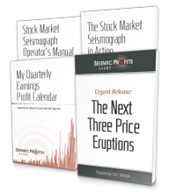
It’s really that simple. But that’s just one small part of it…
You’re also going to get my top-of-the-line research. The market insights and analysis you will receive is valuable in and of itself…
And if you choose to invest in any of my recommendations, it’s important that you read up on this first so you can decide what’s best for you.
If you follow my step-by-step instructions, making these trades is as easy as opening an email… or calling your broker.
Now, to be sure you never miss an opportunity, I’ll even send you a text message when my system alerts me to a new, hot play, telling you to check your email for my latest recommendation.
So you don’t have to sit by your computer waiting for the next trade.
This is optional, of course, but I’ll remind you that these are seven-day profit opportunities. And you need to move on them quickly if you want in.
And that’s the beauty of this seven-day window.
Why on earth would anyone trade 365 days a year, sweating bullets, drinking Maalox, putting hundreds of thousands of dollars at risk in an uncertain market…
When you could play the market for just a few days, invest a small sum, and walk away with $20,521 on only three trades?
I can tell you the profit opportunities here are already coming in fast and furious. There could be hundreds of price explosions in the next few weeks alone...
And I expect my system to uncover dozens of white-hot opportunities.
I would hate for you to miss out on all this action.
And that’s why I’m going to do something special for you today. Remember when I told you about the play on Delta that I expect to make 112% gains? Well…
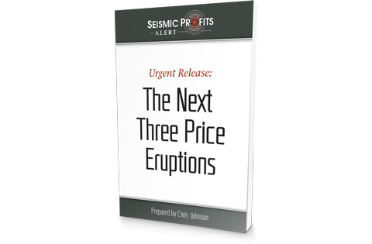
If you decide to come with me today, I’m going to give you THREE FREE TRADE RECOMMENDATIONS, in addition to the 52 that I’ve already promised you.
One is already lining up for a huge win, 112% by my estimates...
The second is targeting 94%...
And the third is moving towards the 103% range.
I’m ready to show you, step by step, exactly how to play these three white-hot opportunities in just a minute.
But first, I want to give you the chance to save a boatload of cash on this research, because I think it’s critical that you have access to this right now.
You can take the cash and spend it any way you want. You can even use it to invest in these plays. It’s entirely up to you.
How much cash are we talking about?
Well…
If you claim one of the 500 Charter Memberships available today… I’ll slash your membership fee by $2,200!
Now, the regular price of my Seismic Profits Alert is $3,950. And quite honestly, it’s worth every penny.
Because, as you’ve seen for yourself, my seismic profits system offers the chance to make some serious money in a very short time.
Like the $27,897 you could have made in just two weeks last October.
But today, you only pay $1,750. Again, that’s a savings of $2,200.
Think of what you could do with that $2,200…
You could put it towards a house, a new car… you could even decide to put it into any of my trade recommendations.
Any one of these three white-hot bonus plays could double your money in seven days or less based on my Richter Score.
That’s enough to easily pay for your subscription… in just seven trading days…
And then you could continue receiving trade after trade for what would be zero cost to you.
And just to give you a little extra peace of mind, I want to give you TWO more reasons to join me today.
Because I’ll give you TWO guarantees when you join as a Charter Member of Seismic Profits Alert right now.
Guarantee #1:
First of all, you get a 90-day, peace-of-mind guarantee.
During those first 90 days, if you commit to reading my material, looking at my alerts, paper trading my recommendations, and honestly seeing for yourself how much money you could be making… enough to pay for the service several times over…
And you still don’t think it’s right for you, just give us a call and my team will refund 100% of your membership fee. Every penny. No questions asked.
When you join today, you could start racking up double-your-money gains right away with your three BONUS plays – which I’m ready to reveal to subscribers in just a moment…
And a whole lot of trades with money-doubling potential are coming right behind that.
That’s why we cannot afford to waste these limited spaces on people who are not serious about this.
Now let me give you guarantee number two.
When you join today, I want to give you the same confidence I have in my system. In fact, I’m going to give you one of the most amazing performance guarantees in the industry.
Guarantee #2:
Eight out of every 10 trades I send you over the next year will be winners. Or you’re guaranteed to get a full, 100% refund on every penny you paid for my service.
That’s right. One year from now, 80% of the recommendations you’ve received from me, as published on our track record, will be closed out as winners...
Or else you just let my team know and you’ll get back a 100% refund on every penny you paid for your subscription.
What’s even better is that – guarantees aside – I’m not expecting just miniscule 9% or 10% returns here. I’m aiming for potential gains of 100% or higher…
And that’s just on average. I fully expect you to see gains well above average, as high as 953% or more.
Plus – as I just mentioned – right now, Seismic Profits opportunities are coming in left and right.
In fact, my system is targeting three hot-profit plays in the next seven trading days. And you can get these recommendations for FREE right now.
But first I need to ask you two serious questions…
Question #1: Are you ready to make a commitment to your financial future? It sounds like a simple question, I know.
But you see, I’ve spent decades developing the absolute best system for trading earnings. It’s based on millions of calculations and hours of detailed analysis. It’s amazing, and it’s been proven capable of producing huge gains in just seven days.
And the slots open here are extremely limited. Now, anyone who wants to can sign up today, but I want only those folks with me who are serious about learning how to make at least $100,000 in the next 12 months. I don’t want to waste a single open slot.
Question #2: Are you ready to be part of a unique experiment to prove just how easy it is to turn $10,000 into $100,000?
Now, let me explain…
This experiment involves you and an individual named Dave Strehle.
Dave and his wife, Angie, have three kids and five grandchildren. He’s worked for the same local trucking company for 24 years, and he’s never made more than $63,000 a year in his life.
Dave just turned 55. He’s getting closer to retirement, and he knows he doesn’t have nearly enough saved.
In fact, his only investing experience involves putting a couple thousand in his 401(k) every year.
I never met Dave before now, but he’s fascinated by what I do. And he agreed to allow me to publicly coach him on how to turn his small sum of $10,000 into $100,000 in the next 12 months.
But we’re not going to stop there. Dave would love to make $1 million, and you could be part of that experiment, too.
So I’m going to videotape my coaching, and you’ll be able to see exactly how Dave progresses… how much money he makes… what mistakes happen – if any – and how long it takes him to make his first $100,000.
Remember, Dave is going to be trading his own real money in real time. So this is a serious experiment.
Now, to be completely clear, Dave isn’t a subscriber or client of any sort. He’s not paying me or Money Morning for this. I’m simply teaching him my strategy because, quite honestly, I know he needs to do something quickly to build his nest egg. Or he’ll never have enough money to retire comfortably.
Here’s where your commitment comes in: I’m going to be using the same trades I recommend for Seismic Profits Alert to train Dave.
And just to make it more challenging – and to prove how effective Seismic Profits Alert can be – Dave won’t be placing any trades until at least 24 hours after I’ve posted them for you. You’re guaranteed first dibs on these trades.
Nonetheless, I need you to follow along with us and give your feedback every step of the way. What makes sense to you, any mistakes you might see Dave make… and if you like, trade right along with us…
Until we achieve our goal of rolling over Dave’s account into $100,000, starting with our first free trade.
And of course, you’ll have plenty of opportunities to do this for yourself.
Provided you’re willing to receive a minimum of 52 trades… all designed to deliver money-doubling profits in seven trading days or less.
You do NOT have to spend hours researching all 23,544 earnings reports to find the best profit plays. Remember, that’s MY job.
But you DO have to spend less than 15 minutes reading your easy-to-follow trade alerts…
And you DO have to watch my coaching videos with Dave…
And I DO urge you, if you decide to use my recommendations, to follow my step-by-step instructions telling you exactly how to place each trade.
In fact, nothing could be simpler. You’ll receive immediate alerts and recommendations… you’ll be part of a group right there with me as I show Dave and you how to achieve your first $100,000.
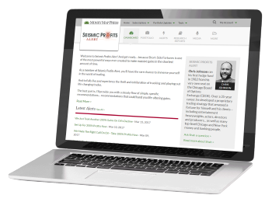
You’ll also have complete access to my 24/7 members-only website, where you can view open recommendations and see exactly how much wealth potential Seismic Profits Alert is delivering for you.
You’ll also get access to our concierge service to answer any administrative questions about your new membership.
This is a team of highly qualified professionals dedicated to helping you get the most out of your Seismic Profits Alert subscription.
You get all of this, PLUS your three FREE trade recommendations, which are ready right now.
And don’t forget, you are also protected by my double guarantee…
Guarantee #1: If in the next 90 days, you aren’t 100% convinced that my proprietary, proven system could help make you very, very rich, I’ll refund your entire subscription fee. No questions asked.
Guarantee #2: If 80% of the trades I send you over the next 12 months are NOT winners, I’ll refund the entire cost of your subscription.
But I’m not worried I’ll have to do that. Not even a little bit.
That’s how confident I am in this system. And how sure I am that you’ll love the profits you can collect thanks to the power of the Richter Scale Score.
So Are You Ready to Make Some Serious Cash?
I want to thank you for sharing your time with me today.
Before I let you go, I want to take one more minute to urge you to become a member of Seismic Profits Alert today. Right now, in fact…
Because when you join today, I’m going to give you THREE FREE TRADE RECOMMENDATIONS, in addition to the 52 I’ve already promised you.
Place these BONUS trades for real or on paper depending on your comfort level. Plus you’ll begin seeing how I coach Dave to his first $100,000…
But you must be 100% committed to learning how to turn these huge price eruptions into triple-digit gains. Otherwise, please do not take this opportunity away from someone else.
Once you’re comfortable with the service, you’ll receive 52 MORE hot and fast-moving recommendations in the next 12 months. More than enough to reach your own goal of $100,000 if you’re so inclined.
Remember, 80% of those trades are GUARANTEED to be winners or I’ll refund every penny you paid to subscribe.
But here’s the catch… only 500 members can get in today at the amazingly low Charter Membership price…
And I have no idea how long these slots are going to be available.
So if you don’t click the button below right now, you may be shut out entirely.
I’m giving you 90 days to test drive the service. And I personally guarantee that my published track record will give you the opportunity to profit from at least 80% of my recommendations.
So when you think about it, you really have very little to lose and a whole lot to gain. This may be your only chance to see how you could, like Dave, turn a small sum into $100,000.
And if you become a member, you’ll even have an opportunity to take it beyond that.
So please act now, or you’ll be kicking yourself for years to come. Time is too precious to not be making money.
I’m looking forward to sharing this amazing wealth-building experience with you.
Sincerely,
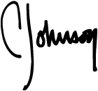
Chris Johnson
Founding Editor, Seismic Profits Alert
April 2017

Copyright - 2017 Money Map Press, LLC. Legal Notices: Visit our Disclaimer page where we provide critical information that will help you use our work appropriately and give you a far better understanding of how our business works - both the benefits it might offer you and the inevitable limitations of our products. Additionally, you can view our company's privacy policy here.

